Flow chart

Nine stages of Big Data analytics

- The flow chart shows the nine stages of big data analytics in detail sequence wise.

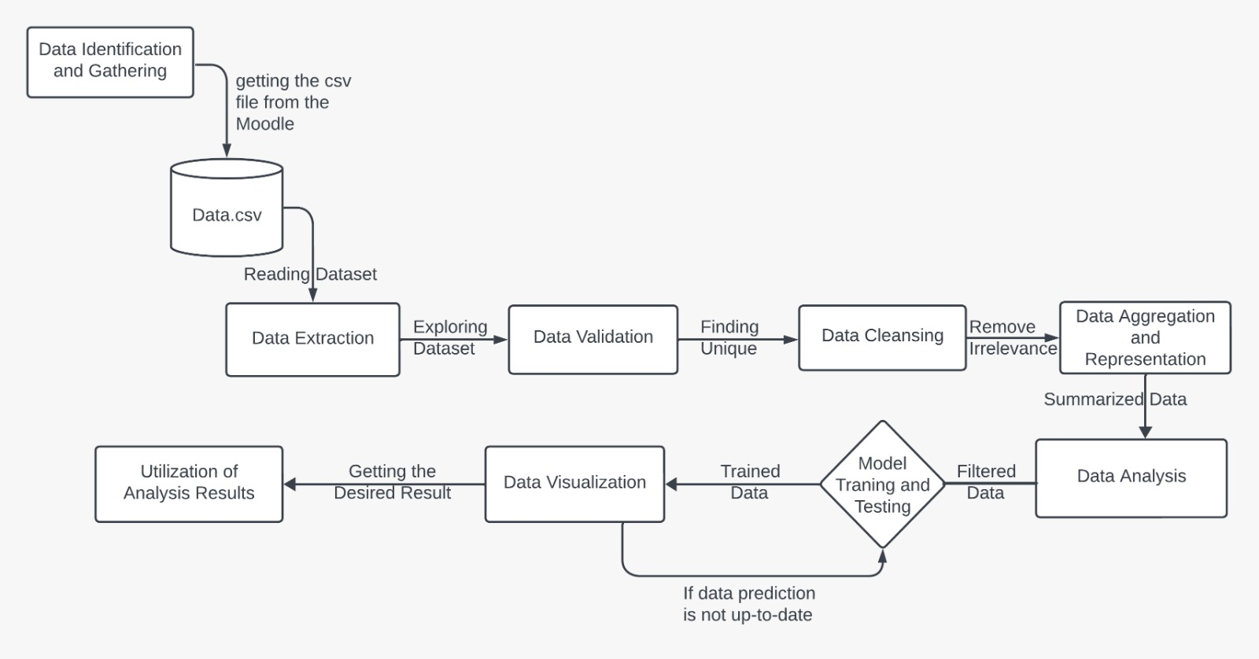

1. Data Loading and Extraction: Loading and extracting the dataset.

1.1. Importing Libraries: Importing the necessary libraries for data pre-processing and analysis such as Pandas, Numpy, MatPlotLib, and Seaborn.

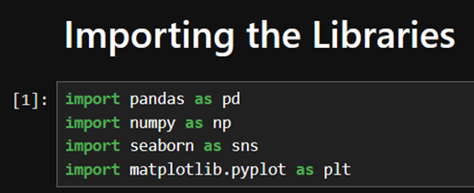
Figure 2.1

1.2. Data Extraction: Extract and take a first look at the dataset.
1.2.1. Pandas.read_csv(): Reads the given dataset in a DataFrame.
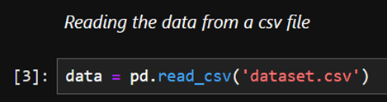
1.2.2. DataFrame.head() and DataFrame.tail(): Displays a few rows for exploring the dataset.
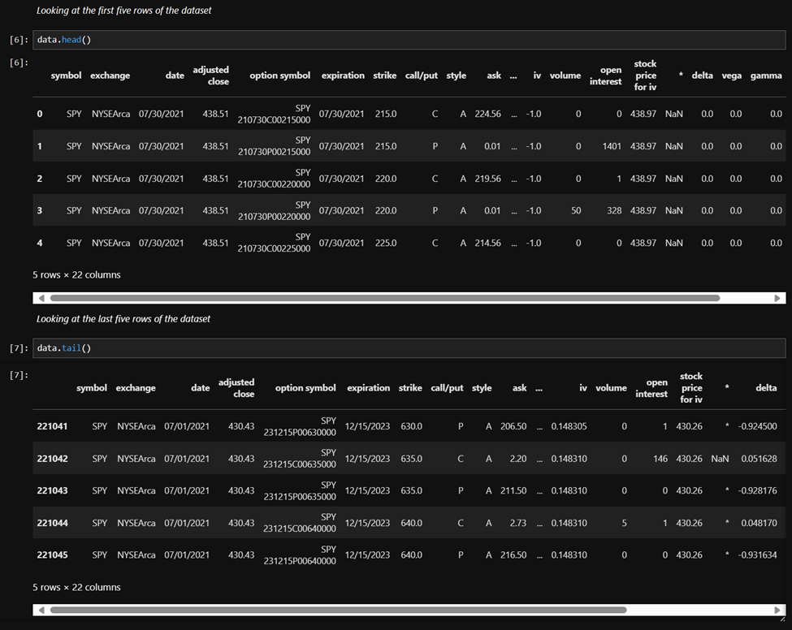

2.Data Validation and Cleansing:

2.1. Data Validation: Validate the dataset.
2.1.1. DataFrame.columns: List of columns to identify features.
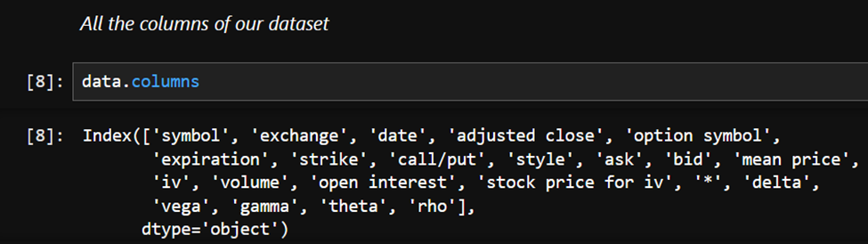
2.1.2. DataFrame.shape: Finding volume of dataset.
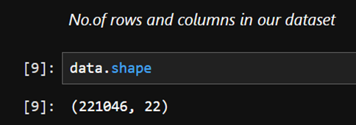
2.1.3. DataFrame.describe(): Describing various mathematical and statistical values in the dataset.
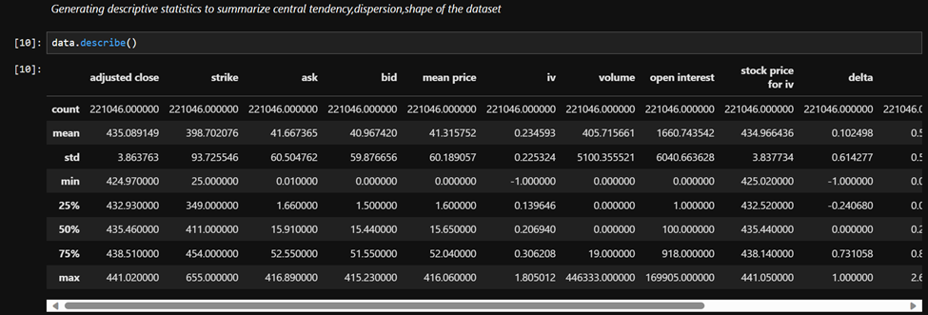
2.1.4. DataFrame.isnull(): Representing the missing values in the dataset.
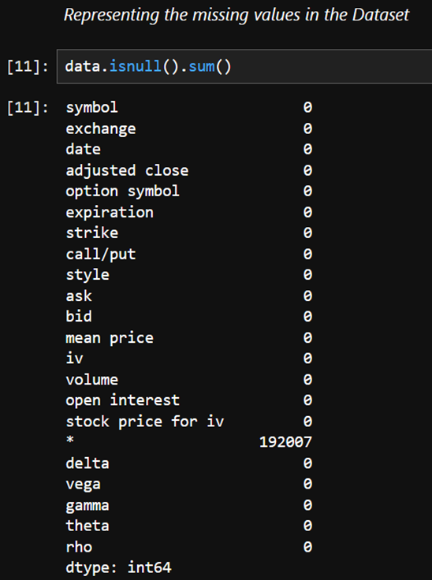

2.1.5. DataFrame.nunique(): Finding the unique values for each column.
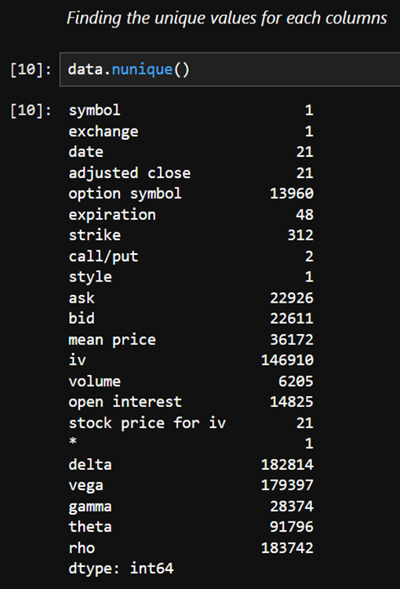
2.2. Data Cleansing: Filter, clean, and refine the dataset.
2.2.1. DataFrame.drop(): Drop the unnecessary fields.
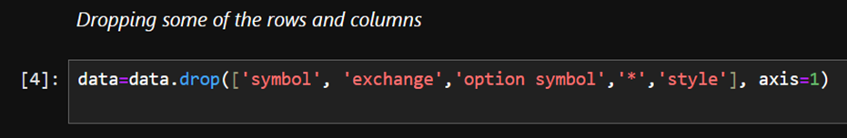
2.2.2. Filtering dataset for further evaluation: Fetching the data until 29th date.
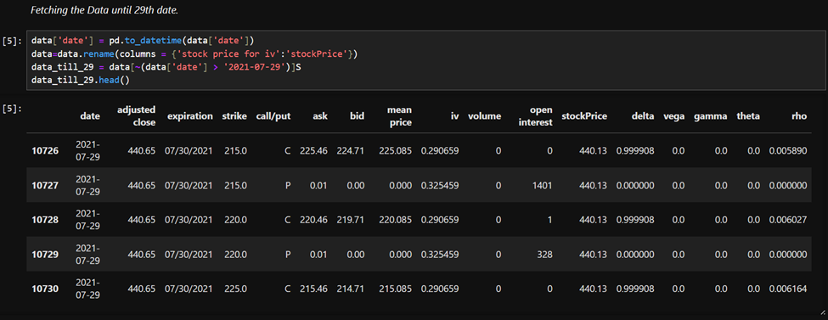

3.Data Representation:

3.1. Date vs Stock Price: Plotting the Date vs Stock Price Graph using relplot() function of seaborn.
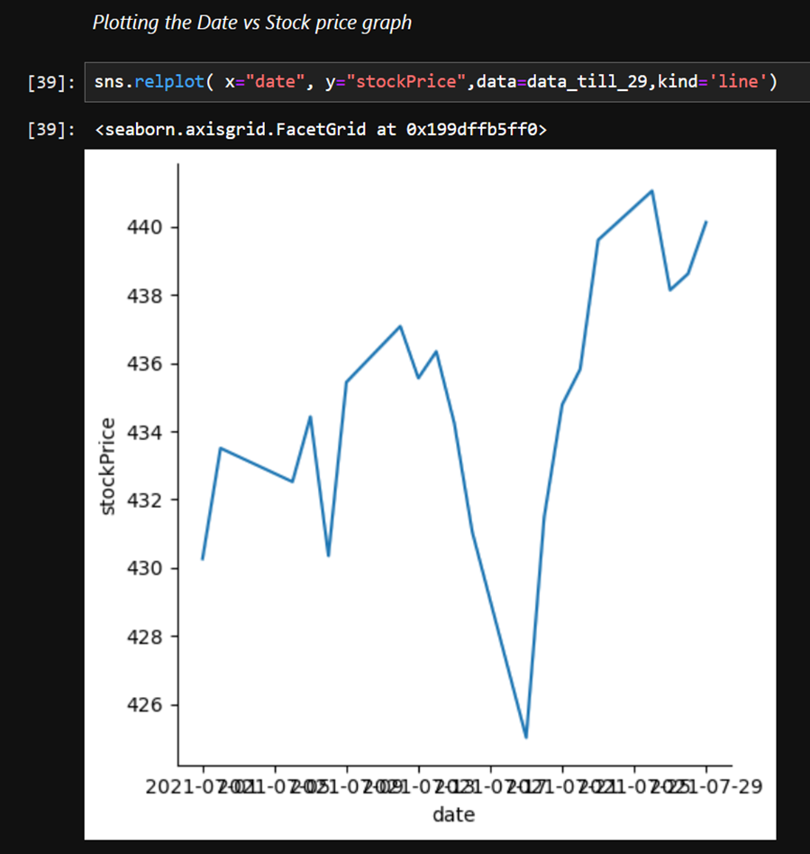

3.2. Stock Price vs Date: Plotting the Stock Price Graph using plot() function of MatPlotLib library.
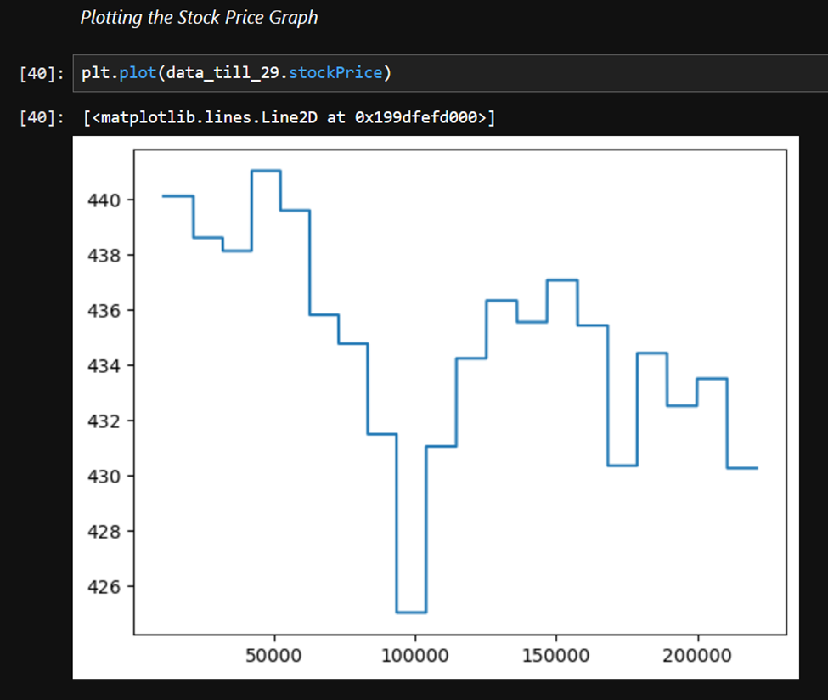

4. Feature Engineering and Data Aggregation

- In this we have to collect the data from the various databases and then we summarize the information as per our need and then we use it for the further process. We can define them using the different graphs. For getting the graph function we need to import the Seaborn library for using the function.
- The Function like boxplot(),barplot(),hist() and many more.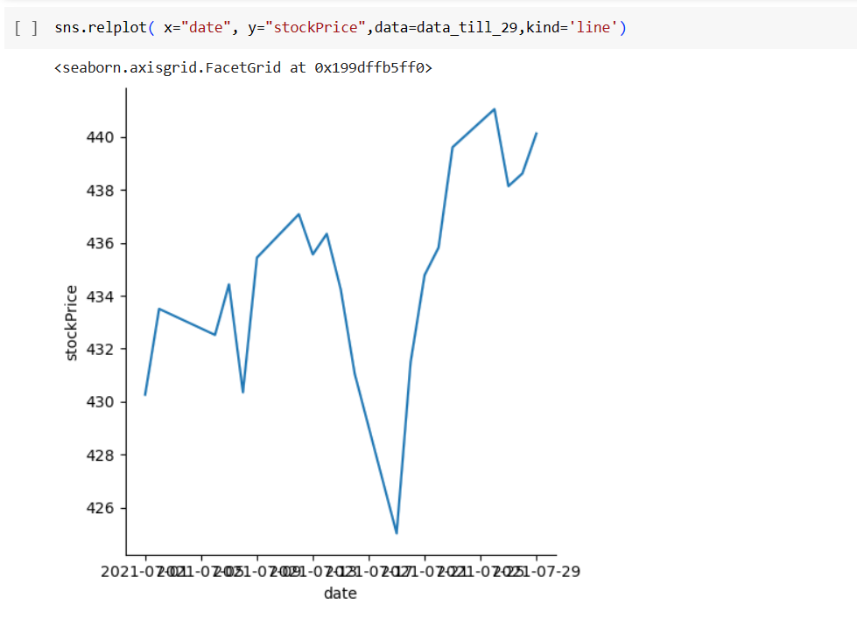
- In the code stock price is on y-axis and date on the x-axis as we are seeing the price of the stock from the 1st of july to 29th july to find the value of it and to predict for the july 31st.

5. Data Analysis

5.1 Cleaning and Rolling of Data

- It is a process of examining,cleansing,transforming and scaling data with the aim of finding the useful pattern to generate the valuable insights.
- In the below code we are using the info() to find the information about the data type of the column, memory usage and how many values does the column have.
- As shown in figure 5.2, the data Rolling() function is used to find the minimum value of the data as per the choice.

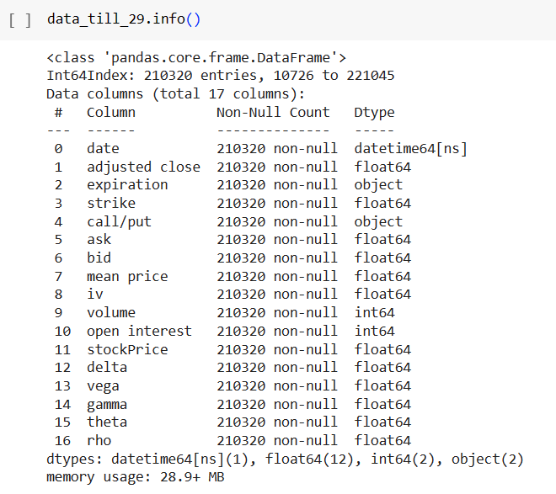
Figure 5.1

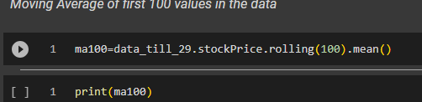
Figure 5.2

Here we are getting the first 100 values to find the mean values and to get that 100 values from the data set we are rolling() and doing it with mean().

6. Data Visualization

6.1 Data Representation

- It is a Graphical Representation of the data in which we represent the data into graph,plot,box and many more.
- Here we are representing the first 100 or 200 values from the data set to find the difference by viewing it and the plot() use in it for making them graphically visible.

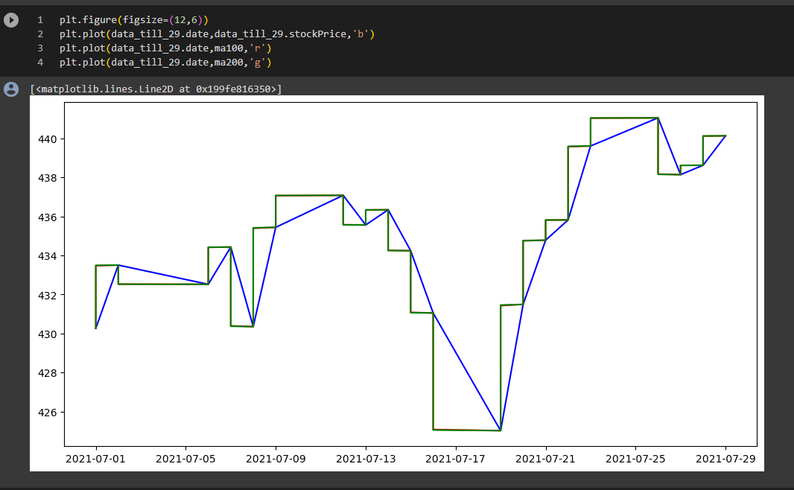
Figure 6.1

6.2 Finding the shape of the dataset

- In this we use the shape() to find the shape of the data which will help us to know of the data.
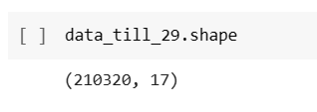
Figure 6.2

7. Model Training

7.1 Importing train_test_split
- For training the data we have to split the data in train and test. This is the most basic and essential part of model training. First, we have to import train_test split from sklearn. The size of the test data is 20 percent and the training is 80 percent.
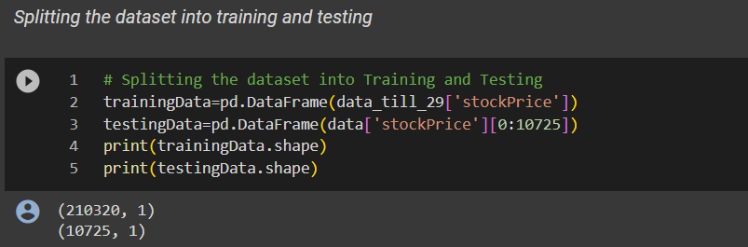
Figure 7.1

7.2 Applying MinMaxScaler

- The variables that are measured on various scales do not contribute equally to model training and model fitting and might end up creating a bias.
- So, this is why we are using MinMaxScaler before training and fitting the model.

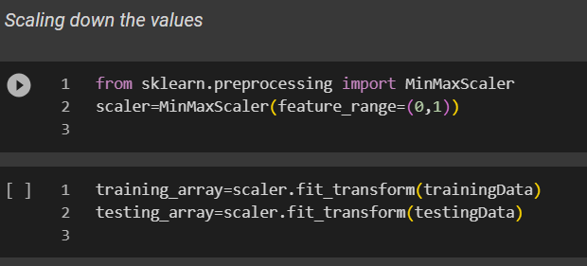
Figure 7.2

7.3 Applying LSTM model

- Importing LSTM Neural Network model from keras
- We imported LSTM and sequential models from keras library which will be used to train the data.
- As shown in Figure 7.4, there are five layers created in this LSTM model and we use “relu” activation function.
- In figure 7.5 the summary of the LSTM model is shown.
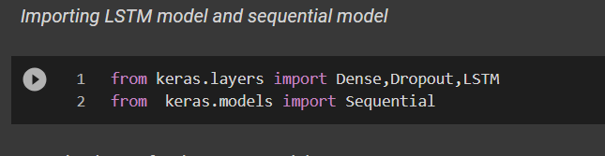
Figure 7.3

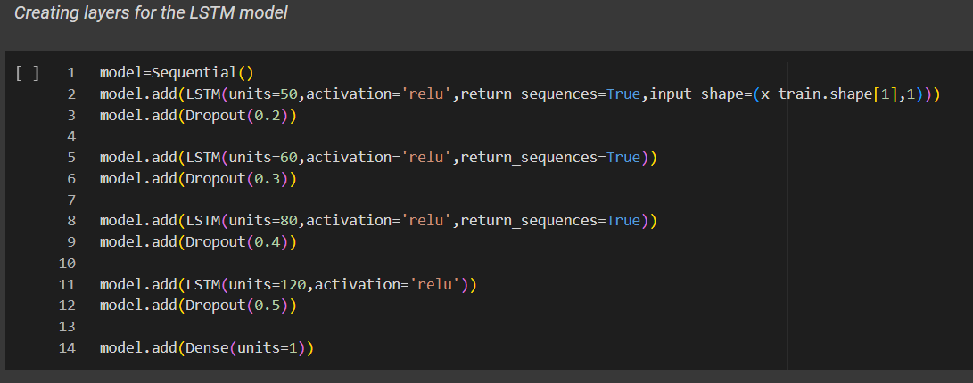
Figure 7.4
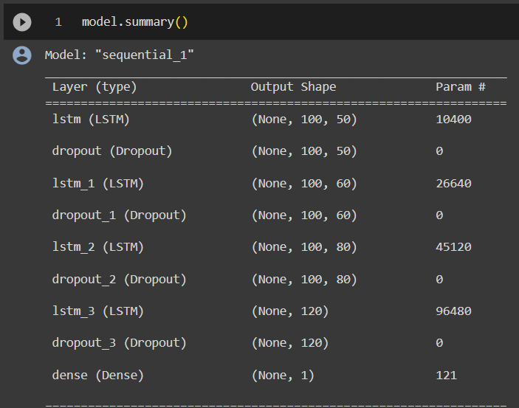
Figure 7.5

- Moreover, we used adam optimizer to optimize our model and the epochs = 4 for the model.
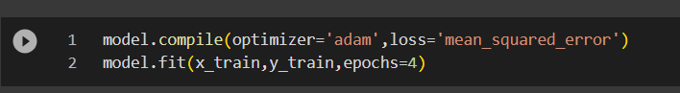
Figure 7.6

8. Prediction and Testing

8.1 Merging the columns for testing

- In this step the first 100 columns of training data are merged to test data.

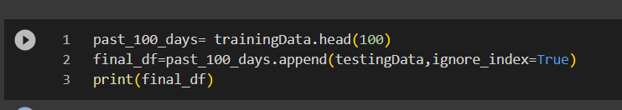
Figure 8.1

8.2 Scaling the data
- Scaling the test data is necessary so we scale the data in this step.

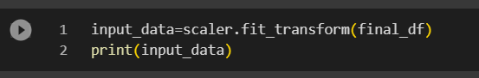
Figure 8.2

8.3 Making predictions.

- As shown in figure 8.3, the model predicted the value of stock price on 30th date.
- Moreover, the prediction is also shown in visualization form in figure 8.4 for better understanding.
- The model predicted that the value of stock price on the 30th date would be around 438.960.
- Furthermore, in figure 8.5 mean_squared_error is used to predict the accuracy of the model. Accuracy depends on the mean_squared_error value.if the value is lesser then accuracy is more or visa versa.

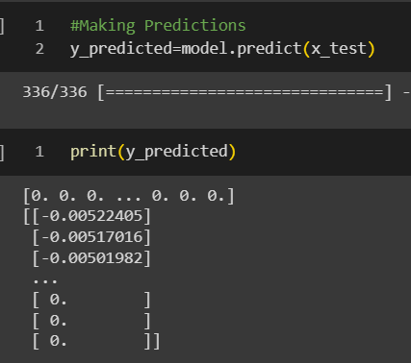
Figure 8.3

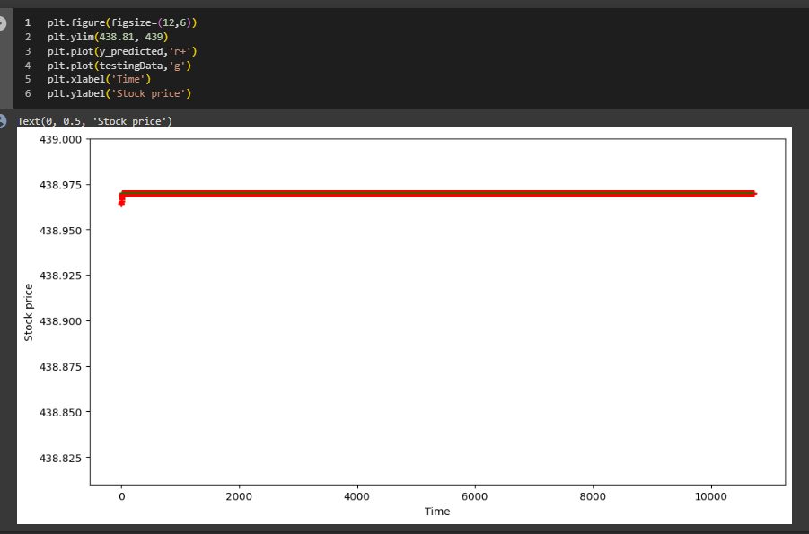
Figure 8.4
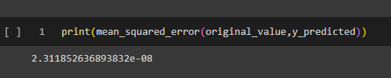
Figure 8.5

9. Validation and matrics (utilization of results)

9.1 Predicted column is added to dataset
- For better understanding the predicted value is concatenated in the dataset as a new feature as shown in figure 9.1 so, It can give better understand of prediction and relation of predicted column.

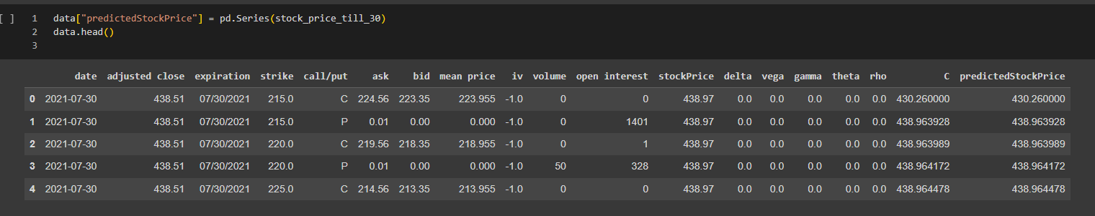
Figure 9.1
9.2 Visualize the updated dataset
- As shown in figure 9.2, Finally, the graph has been plotted to understand the prediction graphically. So, one can understand the result in a better way by just visualizing the plot.

